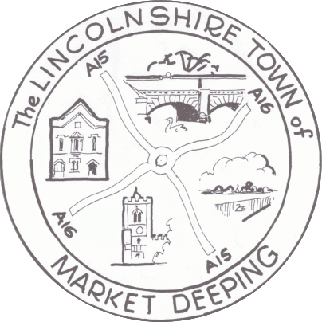
Market Deeping Town Council Telephone: 01778 343170
Town Hall Email: townclerk@marketdeeping-tc.gov.uk
Market Place Web: https://market-deeping.parish.lincolnshire.gov.uk/

Market Deeping
PE6 8EA Town Clerk: Mrs Gail Darnes
__________________________________________________________________________
Notice is hereby given

Of the meeting of Market Deeping Town Council, which will be held on
Wednesday 14th January 2026 at 7.30pm at the Town Hall Chambers, Market Deeping.
The following business will be transacted:
AGENDA

Public forum:

There will be an Open Session prior to the full council meeting, commencing at 7.30pm lasting for a maximum of 30 minutes, where members of the public are invited to address the Town Council. This will include five-minute reports from any County/District Councillors. The full council meeting will commence at 8.00pm or at the closure of the public forum, whichever is the sooner.
- Chairman’s Welcome & Introductions
- To note apologies and accept valid reason for Absence
- Declarations of Interest under the Localism Act 2011
- Acceptance of minutes of meeting held on 10th December 2025
- Reports: Including reports from Committees: Planning and Highways, DNP, AOS, Finance and Personnel, Mayor’s report and the Clerk’s report
- Correspondence to be noted and resolved upon
- Council Finances:
a) Income & Expenditure by Cost Centre
b) Accounts to be paid for December 2025
c) For members to review Council Finances to 31.12.25
d) For members to receive and accept the internal auditor’s report for November 25
e) For members to review the asset register
- For members to ratify the grass cutting agreement for 2026/27
- For members to consider Precept funding for 2026/27 as agreed by Finance and Personnel committee at their meeting on 14th January 2026
- For members to ratify the statement to accompany Council tax bills for 2026/27
- For members to consider, review and adopt the Data Map and risk assessment for MDTC
- For members to receive an update on the liaison with New River Retail - DJ
- For members to consider the decision of the Town Hall and Cemetery Committee to purchase new curtains for the Town Hall.
- For members to consider arrangements for forthcoming events: Chairman’s dinner 27.3.26, Annual Town meeting (suggested date) 21.4.26 and Funday Sunday 12.7.26.
- For members to consider and discuss any points raised in the public session
- Personnel Matters: Consideration to go into Closed Session to discuss: Staff Issues
- To consider items for inclusion on the agenda items for next meeting of the Town Council, to be held at The Town Hall, Market Deeping on 11th February 2026

Mrs Gail Darnes
Clerk to the Council 7 January 2026

